KS1 e-safety Survey results
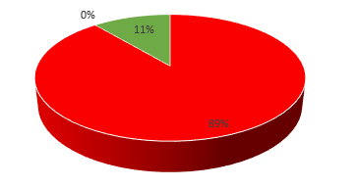

71 surveys in KS1 were completed in November 2021.

Out of this 89% of children demonstrated a poor understanding of the online risks they may encounter.
0% of children demonstrated a level of vulnerability. They have some understanding of the dangers which can be found online but overall require further understanding of the online risks posed to them.
11% of children demonstrated competency and have a good knowledge of the online challenges they may face. However, these challenges and risks are constantly evolving.

When considered in more depth, the answers provided by KS1 showed that 15% of children felt they had no rules for technology at home. 97% of children knew that school has rules for technology in place. 30% of children felt that technology posed no risk to them.
69% of children felt people could not tell lies when talking through technology. 82% of children felt that their name and the name of the school they attend was not private information. 80% felt it was okay to share their password. More work needs to be done in KS1 over what privacy is and what it includes.

