Results of Parent eaware survey
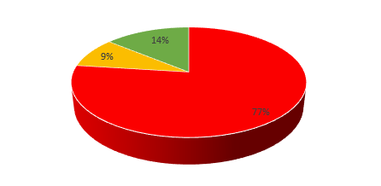

Out of a potential 270 surveys, 100 were completed. This represents 37% of the school’s parents from Year 1 – Year 6.

Out of this 100, 77% of parents demonstrated a poor understanding of the online risks their children may encounter.
9% of parents demonstrated a level of vulnerability. They have some understanding of the dangers which can be found online but overall require further understanding of the online risks posed to their children.
14% of parents demonstrated competency and have a good knowledge of the online challenges their children may face. However, these challenges and risks are constantly evolving.
When considered in more depth the answers provided by the parents, showed that 25% of parents allow their children to be online without an adult present in the room, 7% of adults allow children to speak to people they do not know. 11% allow children to use technology before bed. 11% believe their child does not think technology can be dangerous/put them at risk.

The OFSTED framework requires schools to “work closely with all families to help them ensure that their children use new technologies safely and responsibly both at home and at school.”
With an ever changing society and a necessity for an online presence in our children’s future, it is imperative that the parents and school work together to ensure our children are well educated in e-safety and in understanding their digital footprint. As technology advances, children will inevitably become more informed on new technology than parents so there is a real need to be as informed as possible.

